Geometry: Unit 9, Lesson 7

- What is the sum of $414.179+28.417+78.897$? Round your answer to the nearest hundredth.

$$521.49$$

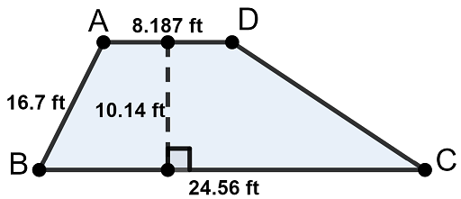
- Find the area of the trapezoid.

$$166.03 ft$$

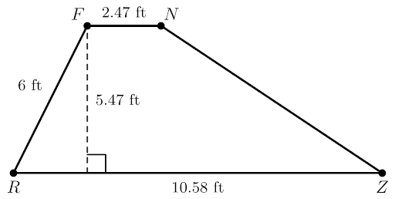
- Trapezoid $FNZR$ is shown where $FN=2.47$ feet $(ft)$, $RZ=10.58 ft$, $FR=6 ft$, with a height of $5.47 ft$. What is the area of trapezoid $FNZR$?

$$35.69 ft^{2}$$

